1. 
2. First we have to decide which one is to use either Bounded Type or Wild Card (Upper or Lower).
3. 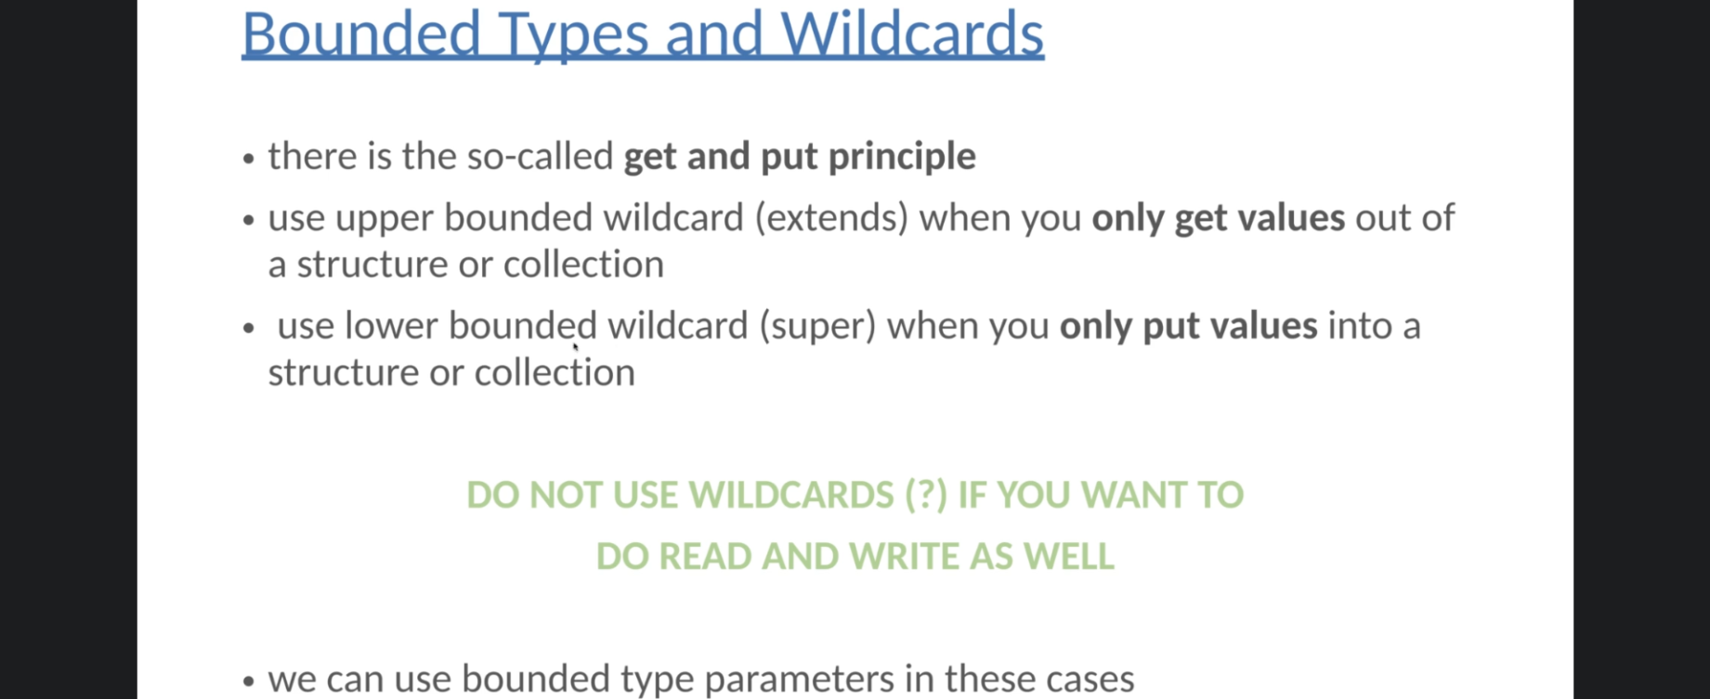
4. 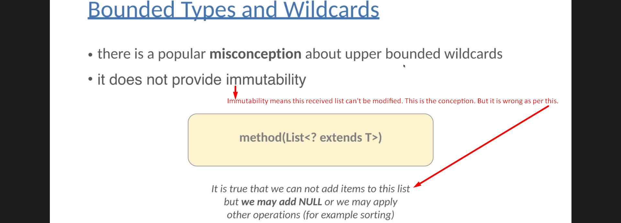
5. 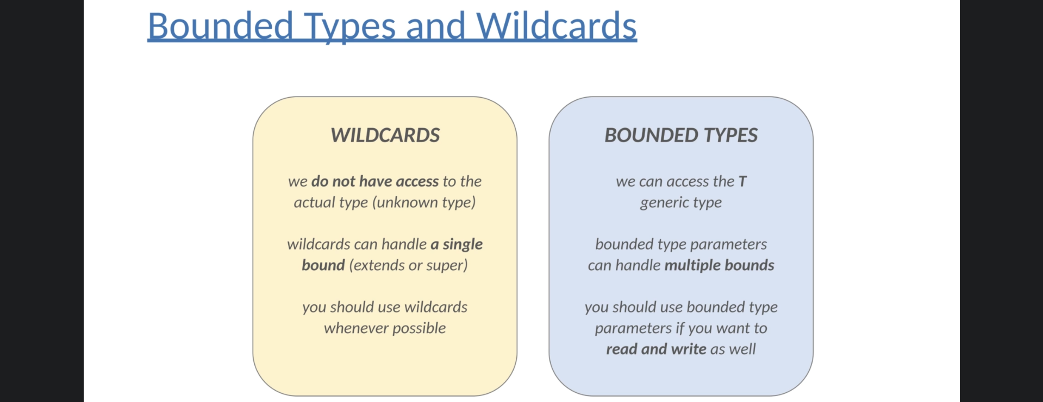

|  |  |
| --- | --- |
| **Bounded Type** | **Wild Card** |
| It can be used only with class and method. **Method Header**: public <T> void display(T String) | With class, method and local variable. Actually anywhere. **Method Header**: public void display(T String) |
|  |  |